The Effect of Laundry Powder on the Fertility of Caucasian Guppies

Dagobert Duck and Mickey Mouse*
¹MickeyMouse University, Dagobert Street 15, 6666 Entenhausen, Germany
monkey@mickeymouse-university.com

The increasing flow of common household cleaning agents into natural waterways represents a significant, yet frequently ignored, environmental concern regarding aquatic life. This study focused on assessing the consequences of a popular, high-phosphate laundry powder, referred to here as 'Bleach-BrightTM', on the reproductive capacity of a sensitive ornamental species, the Caucasian Guppy (Poecilia rzakhana). While the accidental introduction of surfactants is often thought to only cause foam or slight water cloudiness, the true impact on the complex hormonal and physiological processes of breeding fish must be accurately quantified. This research aimed to establish a clear relationship between the level of detergent pollution and the total number of live offspring produced by the guppy population over a standardized breeding cycle.
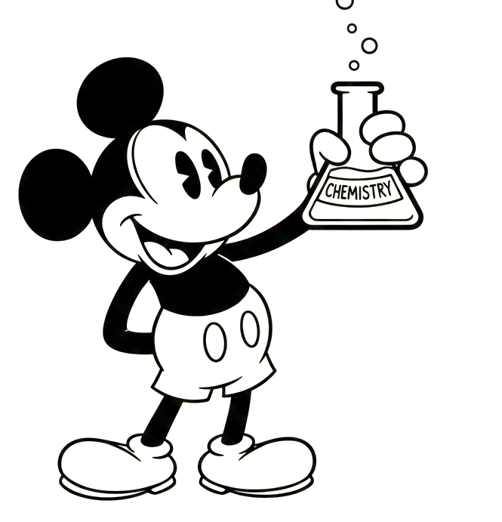
We established four distinct experimental groups of Caucasian Guppies. Each group was composed of sixty adult fish (an equal ratio of 30 males to 30 females). To ensure the reliability of our findings, the entire experiment was conducted three separate times. All aquaria were kept at an ideal tropical temperature and the fish were fed a standard flake diet twice daily. We tested four concentrations of the 'Bleach-BrightTM' laundry powder, ranging from a normal environment (zero detergent) to very high levels of contamination. The reproductive success of the fish was observed and tracked over a period of forty-five days, during which time we carefully counted the total number of surviving baby fish produced by each female. We also recorded daily behavior, looking for changes in activity, feeding habits, and male courtship displays.

The results showed startling and varied effects across the different concentration levels. In the group exposed to the lowest concentration of laundry powder, we observed a notably higher number of male courtship rituals, including more frequent and vigorous fin-flaring displays. However, despite this increased romantic effort, the total count of viable offspring did not increase. The group exposed to a medium level of detergent showed minimal change in both behavior and reproductive output, remaining similar to the clean control group. The most dramatic effects were seen in the group exposed to the highest level of detergent. In these tanks, the fish experienced complete reproductive failure, with zero baby fish recorded. Curiously, the high-concentration exposure also caused the fish to develop an unexpected aesthetic trait: their scales took on a striking, iridescent blue-green sheen. This unexpected physical change did not correlate with any observable improvement in the health or behavior of the fish, which often appeared lethargic.

References
[1] …
[2] …
[3] …
[4] …
[5] …

